# E-Vehicle Routing with Parking System

Aryaman Mishra, Dr. Suguna M

B.Tech CSE, VIT Chennai

***Abstract*-** Mention the abstract for the article. An abstract is a brief summary of a research article, thesis, review, conference proceeding or any in-depth analysis of a particular subject or discipline, and is often used to help the reader quickly ascertain the paper's purpose. When used, an abstract always appears at the beginning of a manuscript, acting as the point-of-entry for any given scientific paper or patent application.

***Index Terms***- About four key words or phrases in alphabetical order, separated by commas. Keywords are used to retrieve documents in an information system such as an online journal or a search engine. (Mention 4-5 keywords)

1. Introduction

T

his article guides a stepwise walkthrough by Experts for writing a successful journal or a research paper starting from inception of ideas till their publications. Research papers are highly recognized in scholar fraternity and form a core part of PhD curriculum. Research scholars publish their research work in leading journals to complete their grades. In addition, the published research work also provides a big weight-age to get admissions in reputed varsity. Now, here we enlist the proven steps to publish the research paper in a journal.

Identify the constructs of a Journal – Essentially a journal consists of five major sections. The number of pages may vary depending upon the topic of research work but generally comprises up to 5 to 7 pages. These are:

1. Abstract
2. Introduction
3. Research Elaborations
4. Results or Finding
5. Conclusions

**In Introduction you can mention the introduction about your research.**

1. IDENTIFY, RESEARCH AND COLLECT IDEA

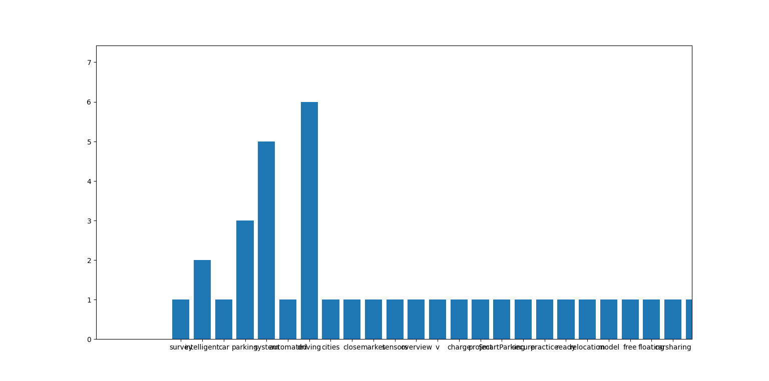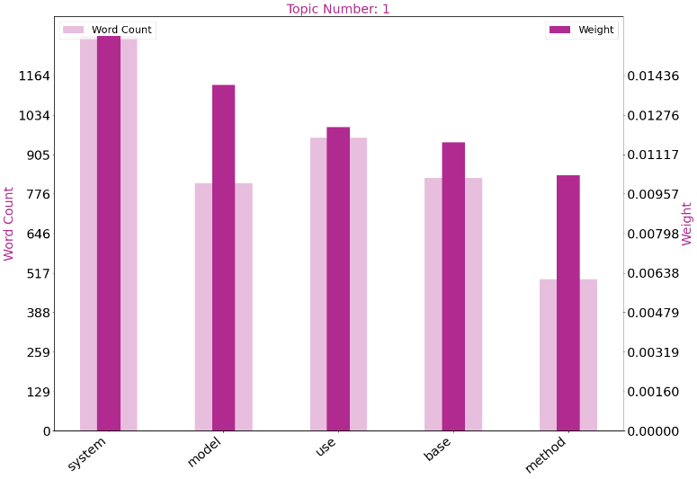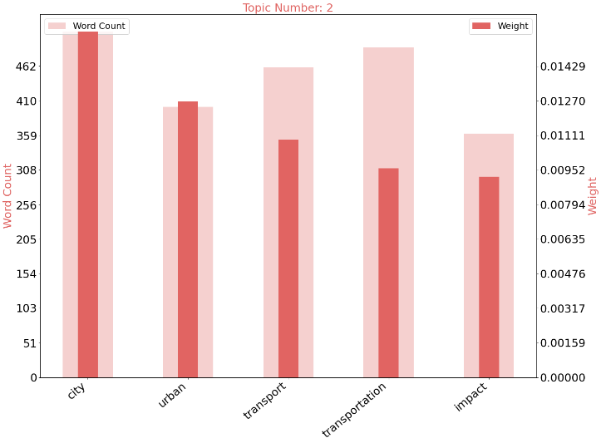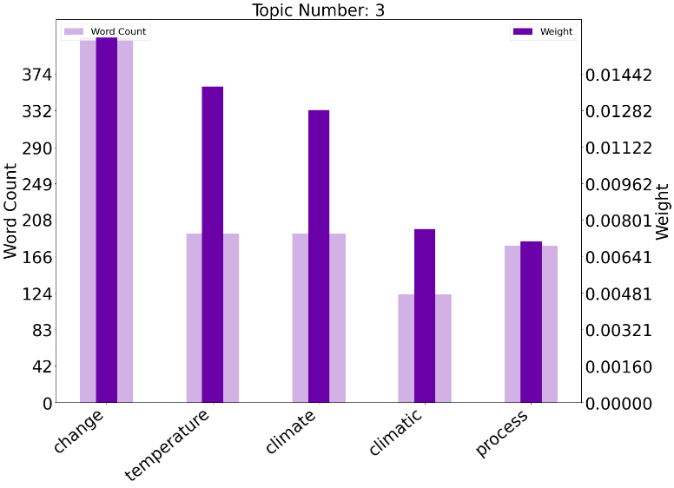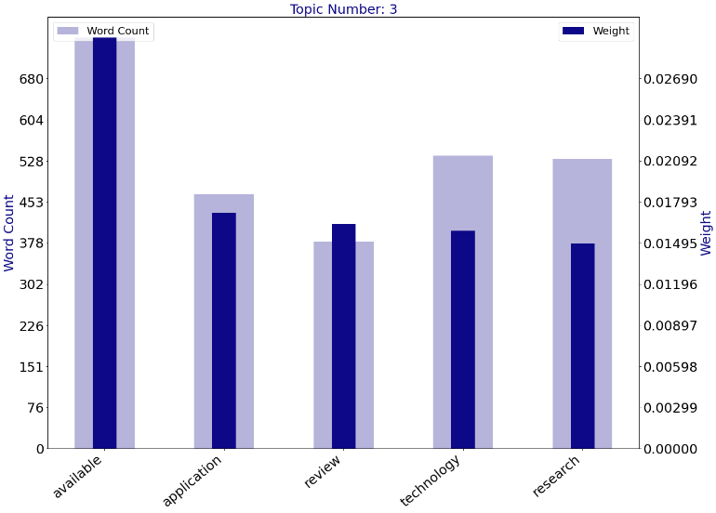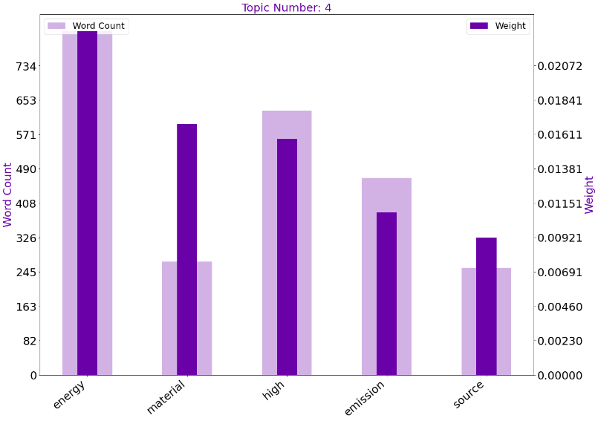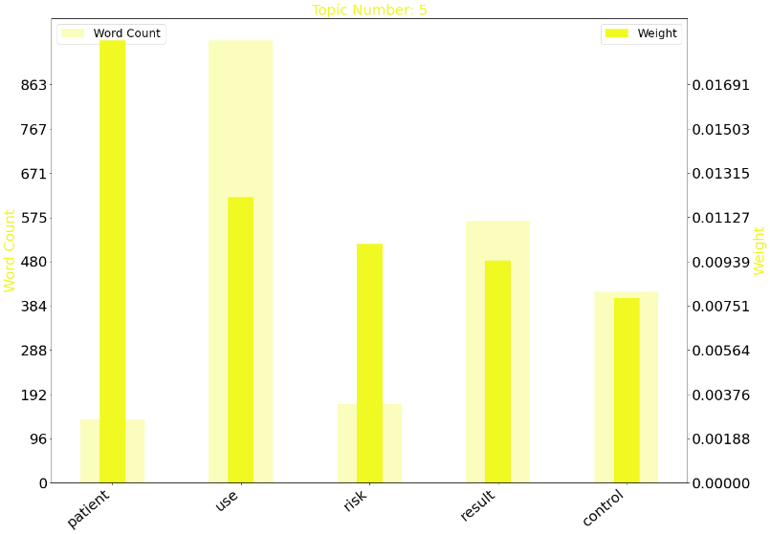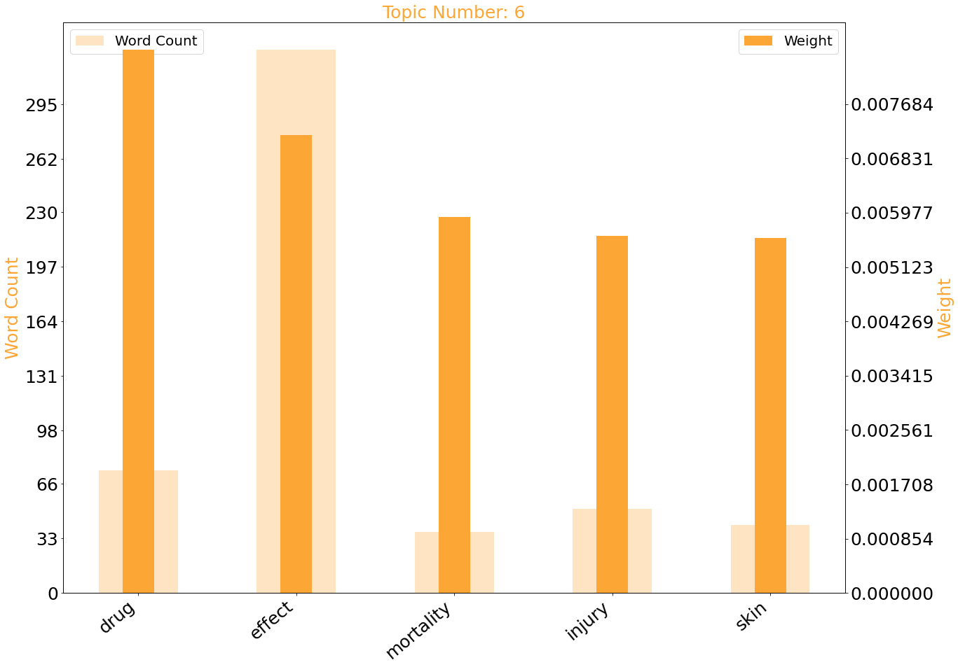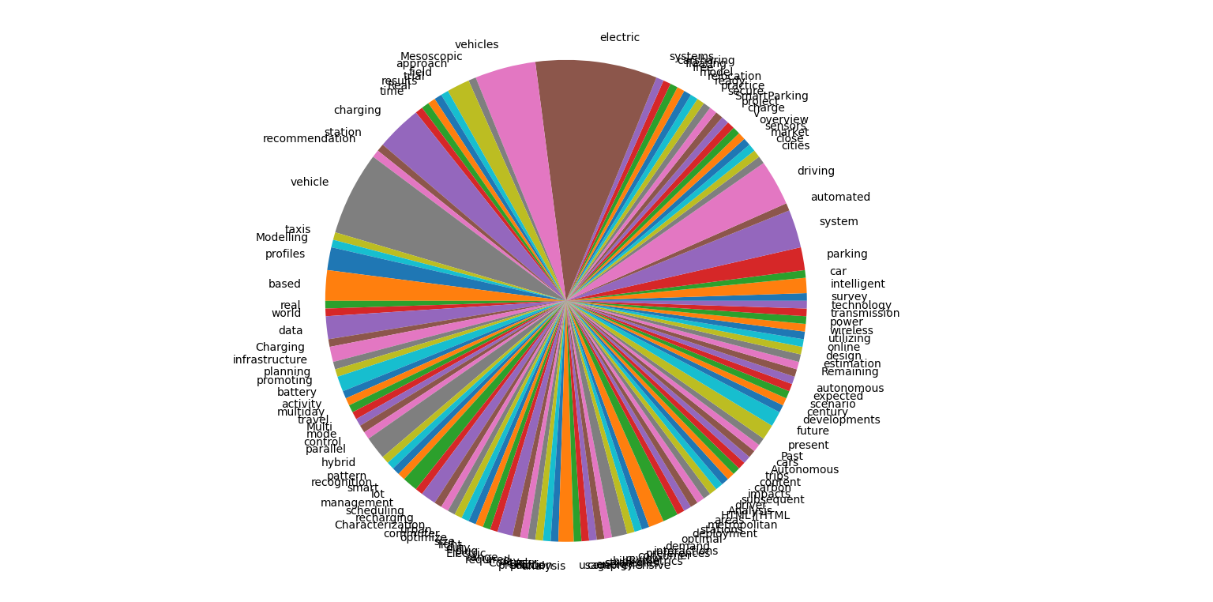

1. WRITE DOWN YOUR STUDIES AND FINDINGS

Now it is the time to articulate the research work with ideas gathered in above steps by adopting any of below suitable approaches:

## A. Bits and Pieces together

In this approach combine all your researched information in form of a journal or research paper. In this researcher can take the reference of already accomplished work as a starting building block of its paper.

Jump Start

This approach works the best in guidance of fellow researchers. In this the authors continuously receives or asks inputs from their fellows. It enriches the information pool of your paper with expert comments or up gradations. And the researcher feels confident about their work and takes a jump to start the paper writing.

## B. Use of Simulation software

There are numbers of software available which can mimic the process involved in your research work and can produce the possible result. One of such type of software is Matlab. You can readily find Mfiles related to your research work on internet or in some cases these can require few modifications. Once these Mfiles are uploaded in software, you can get the simulated results of your paper and it easies the process of paper writing.

As by adopting the above practices all major constructs of a research paper can be written and together compiled to form a complete research ready for Peer review.

1. GET PEER REVIEWED

Here comes the most crucial step for your research publication. Ensure the drafted journal is critically reviewed by your peers or any subject matter experts. Always try to get maximum review comments even if you are well confident about your paper.

**For peer review send you research paper in IJSRP format to** [**editor@ijsrp.org**](mailto:editor@ijsrp.org)**.**

1. IMPROVEMENT AS PER REVIEWER COMMENTS

Analyze and understand all the provided review comments thoroughly. Now make the required amendments in your paper. If you are not confident about any review comment, then don't forget to get clarity about that comment. And in some cases there could be chances where your paper receives number of critical remarks. In that cases don't get disheartened and try to improvise the maximum.

**After submission IJSRP will send you reviewer comment within 10-15 days of submission and you can send us the updated paper within a week for publishing.**

This completes the entire process required for widespread of research work on open front. Generally all International Journals are governed by an Intellectual body and they select the most suitable paper for publishing after a thorough analysis of submitted paper. Selected paper get published (online and printed) in their periodicals and get indexed by number of sources.

**After the successful review and payment, IJSRP will publish your paper for the current edition. You can find the payment details at:** [**http://ijsrp.org/online-publication-charge.html**](http://ijsrp.org/online-publication-charge.html)**.**

1. CONCLUSION

A conclusion section is not required. Although a conclusion may review the main points of the paper, do not replicate the abstract as the conclusion. A conclusion might elaborate on the importance of the work or suggest applications and extensions.

Appendix

Appendixes, if needed, appear before the acknowledgment.

Acknowledgment

The preferred spelling of the word “acknowledgment” in American English is without an “e” after the “g.” Use the singular heading even if you have many acknowledgments.

References

1. G. O. Young, “Synthetic structure of industrial plastics (Book style with paper title and editor),” in *Plastics*, 2nd ed. vol. 3, J. Peters, Ed. New York: McGraw-Hill, 1964, pp. 15–64.
2. W.-K. Chen, *Linear Networks and Systems* (Book style)*.* Belmont, CA: Wadsworth, 1993, pp. 123–135.
3. H. Poor, *An Introduction to Signal Detection and Estimation*. New York: Springer-Verlag, 1985, ch. 4.
4. B. Smith, “An approach to graphs of linear forms (Unpublished work style),” unpublished.
5. E. H. Miller, “A note on reflector arrays (Periodical style—Accepted for publication),” *IEEE Trans. Antennas Propagat.*, to be published.
6. J. Wang, “Fundamentals of erbium-doped fiber amplifiers arrays (Periodical style—Submitted for publication),” *IEEE J. Quantum Electron.*, submitted for publication.

Authors

**First Author** – Author name, qualifications, associated institute (if any) and email address.

**Second Author** – Author name, qualifications, associated institute (if any) and email address.

**Third Author** – Author name, qualifications, associated institute (if any) and email address.

**Correspondence Author** – Author name, email address, alternate email address (if any), contact number.